Practice Questions Week 6

Write a Python program to create a lambda function that adds 15 to a given number passed in as an argument.

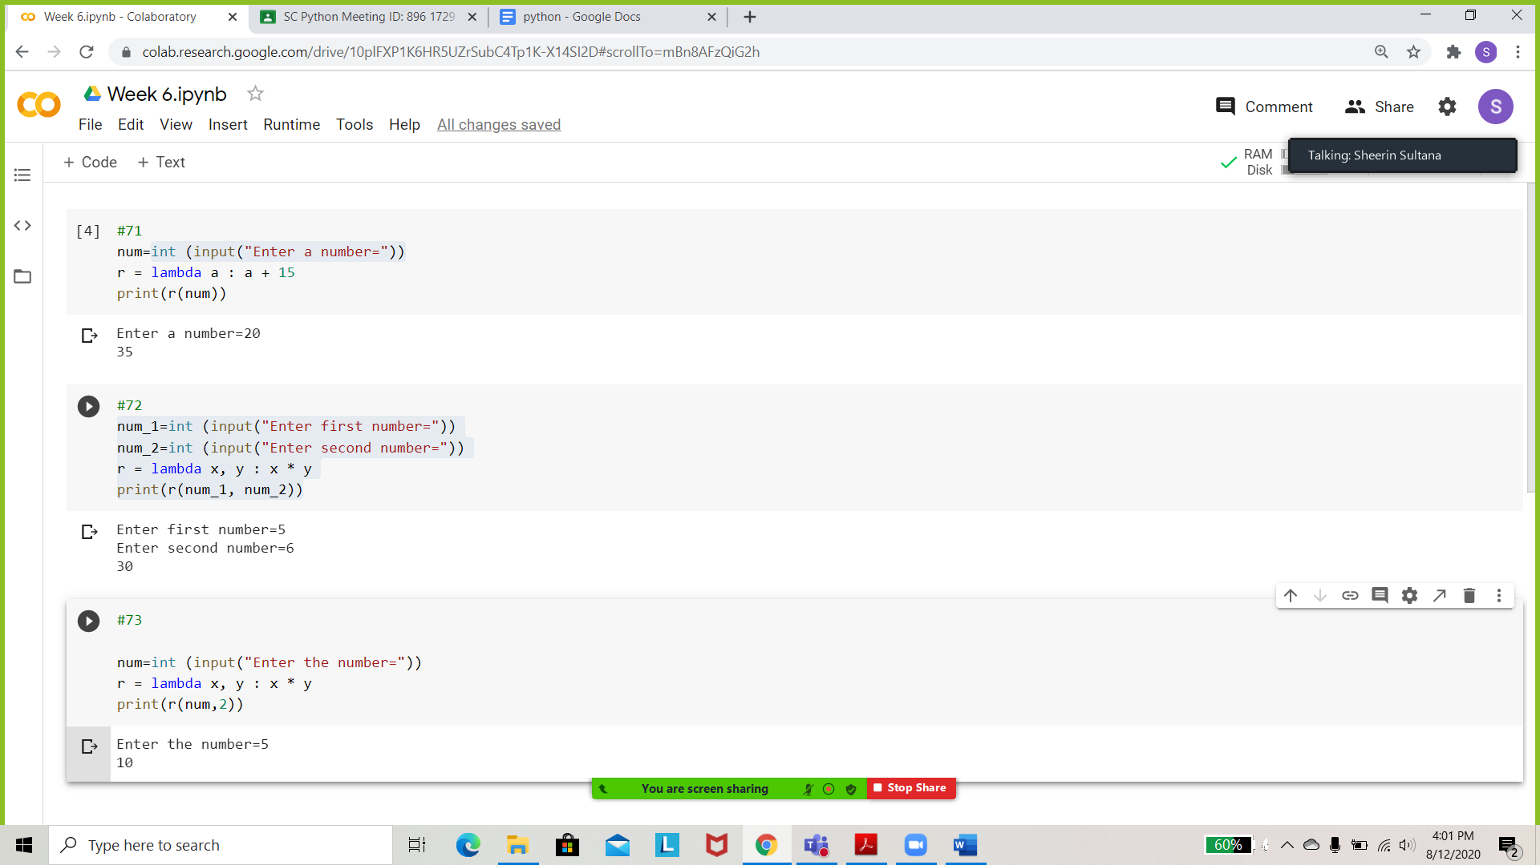

Create a lambda function that multiplies argument x with argument y and print the result.



Write a Python program to create a function that takes one argument, and that argument will be multiplied with an unknown given number.



Write a Python program to find whether a given string starts with a given character using Lambda.

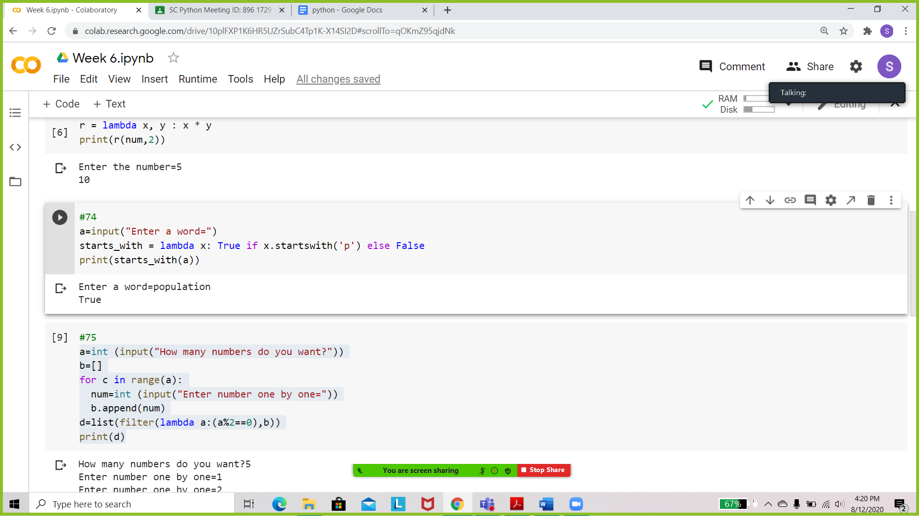 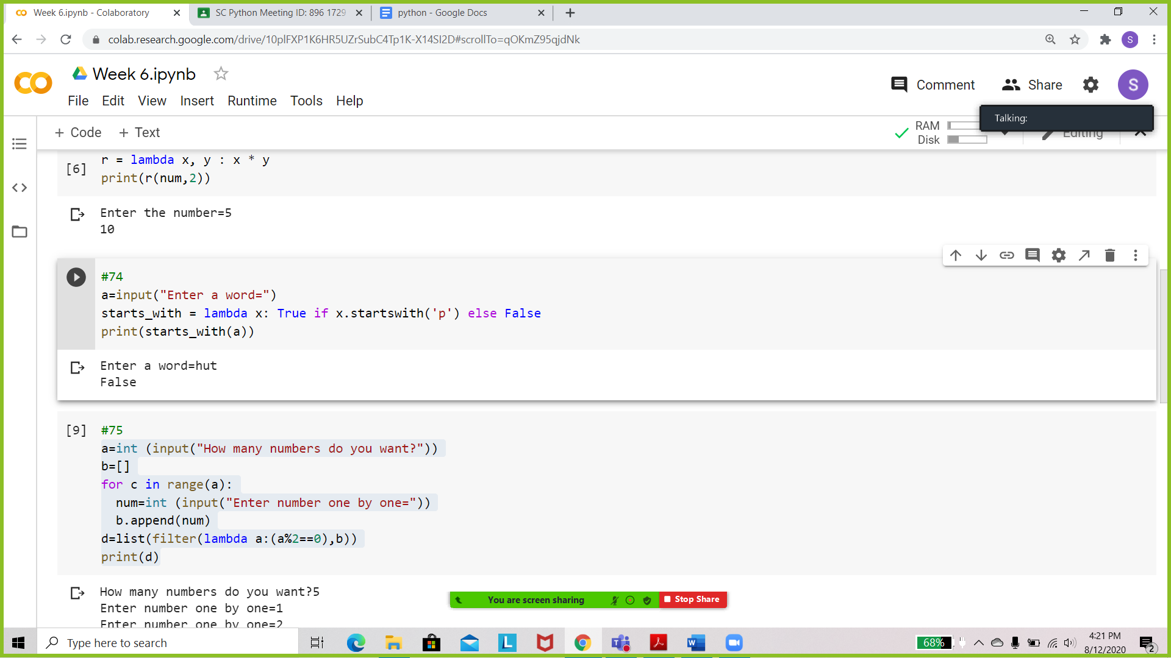

Write a Python program to filter a list of even numbers using Lambda.

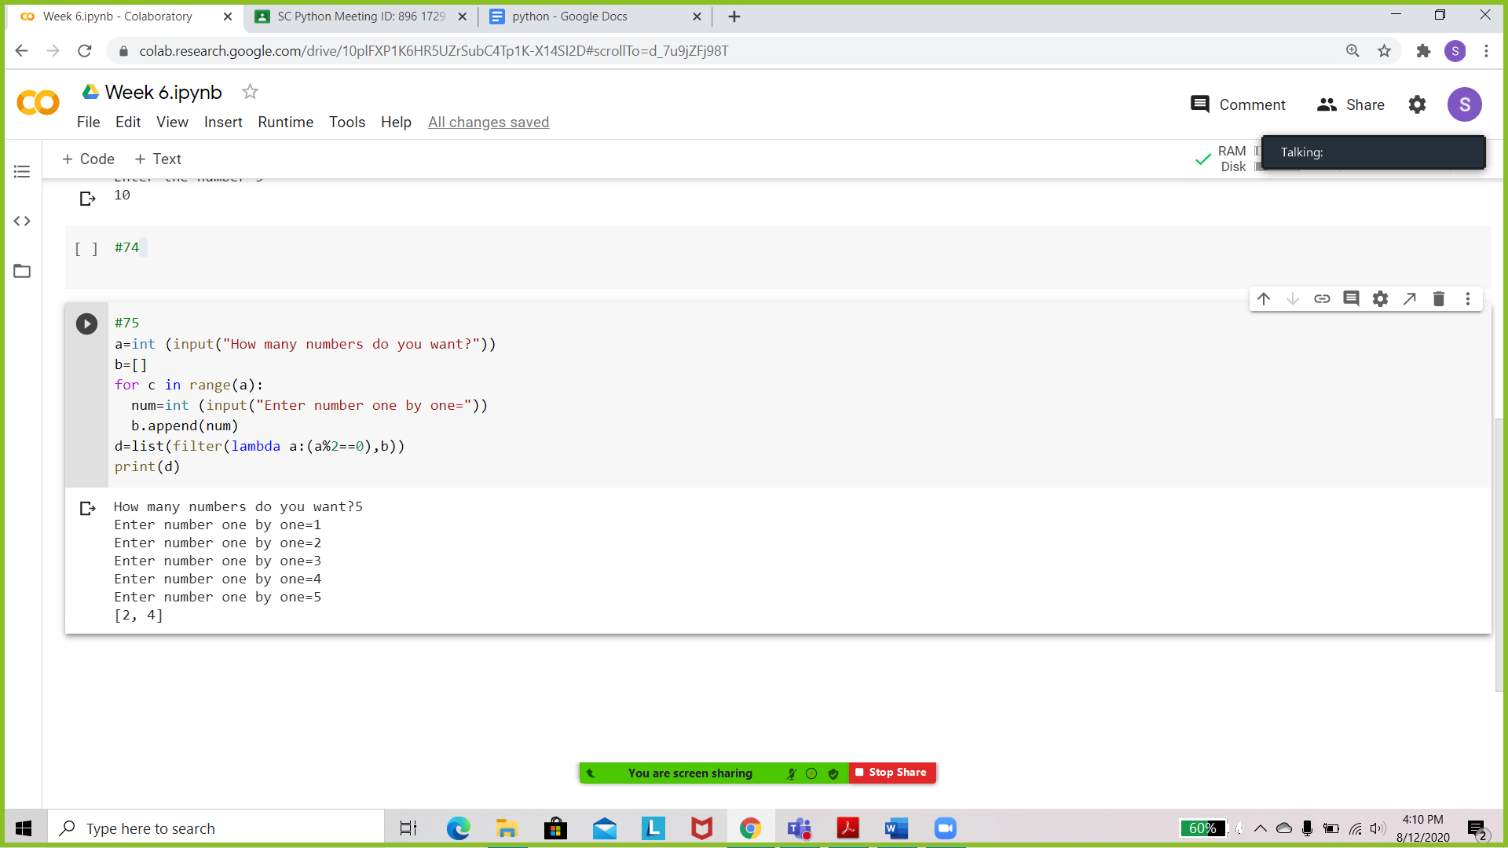

Write a Python program to filter a list of odd numbers using Lambda.

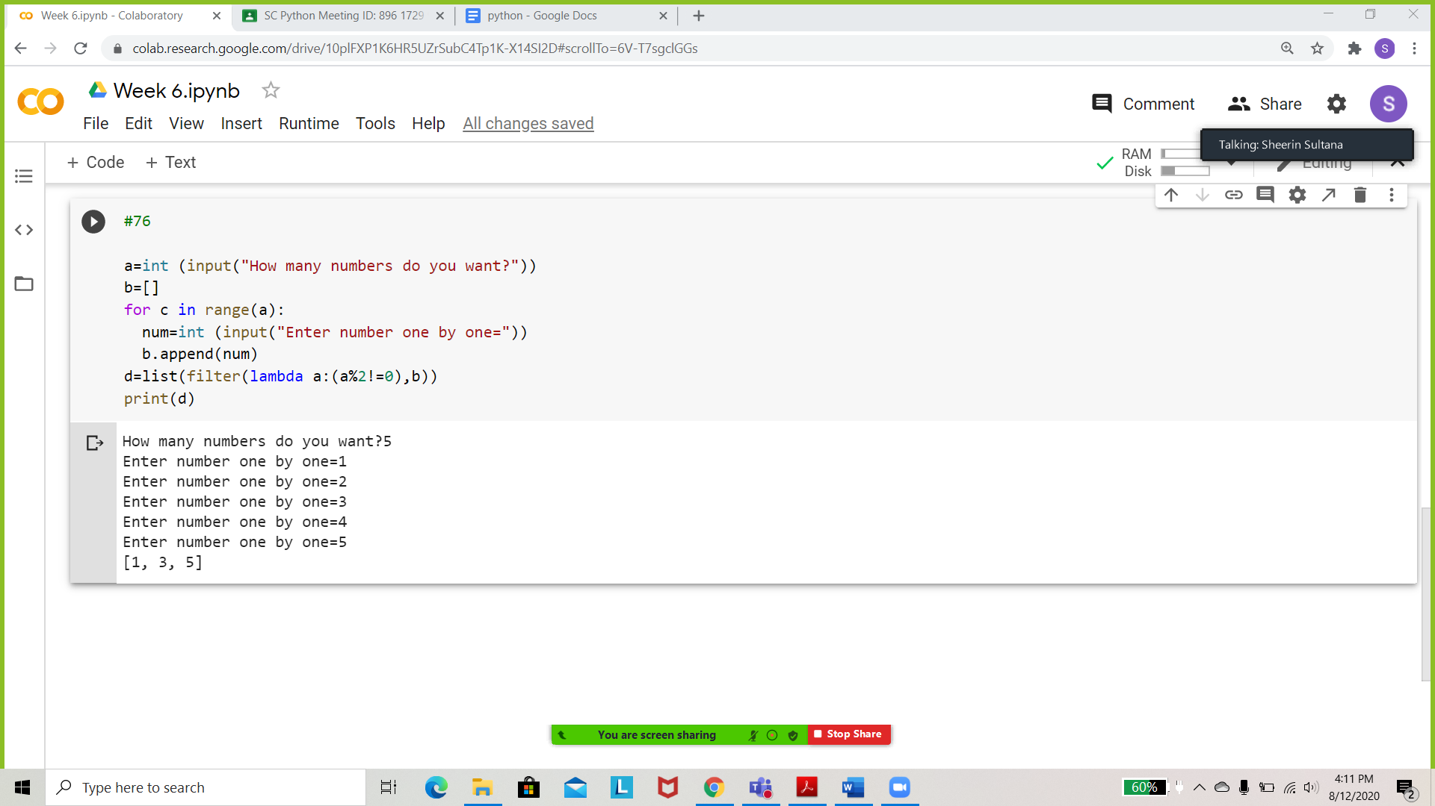

Define a function - water that takes a single temperature parameter (in degrees Celsius), and prints whether the water is a solid, liquid, or gas.

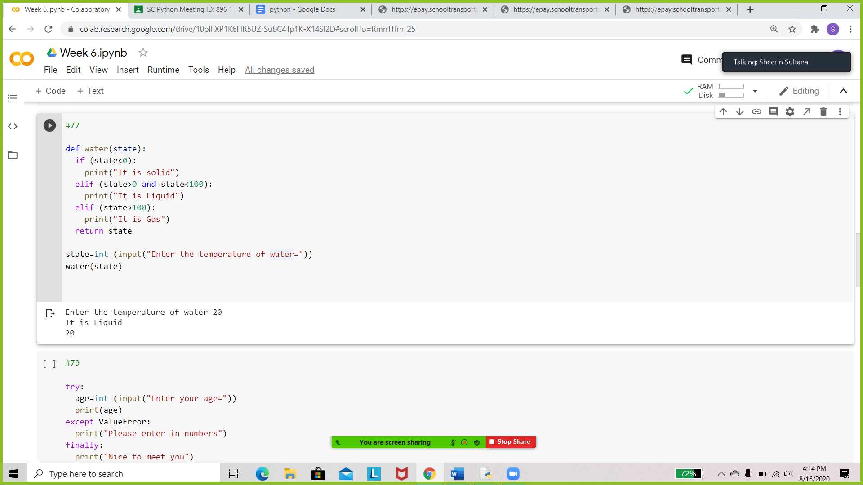 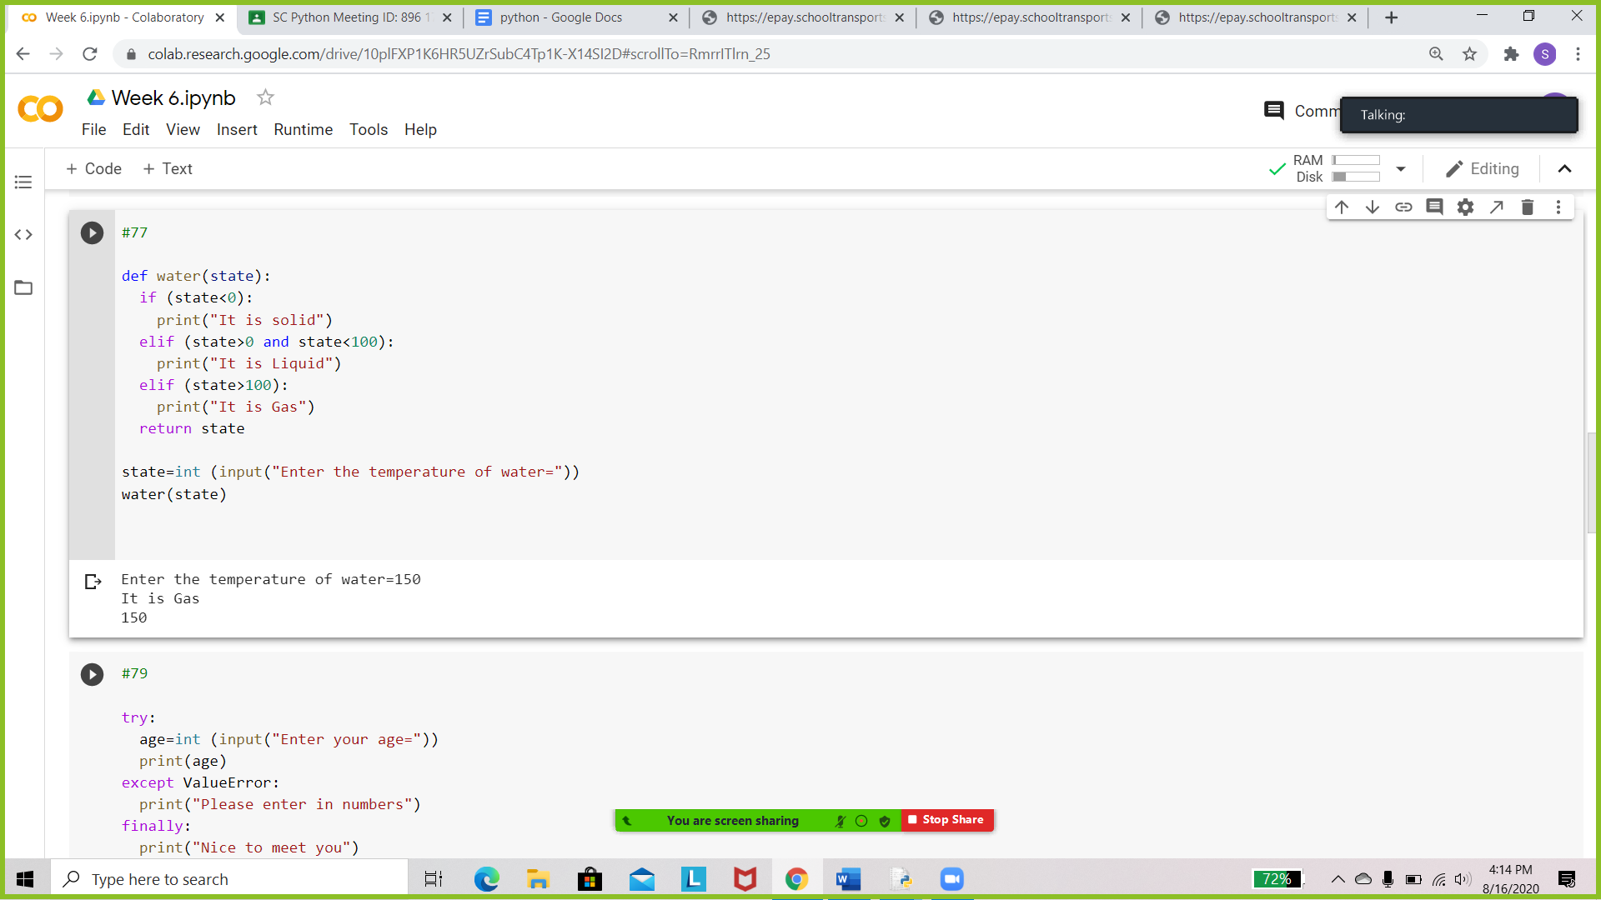

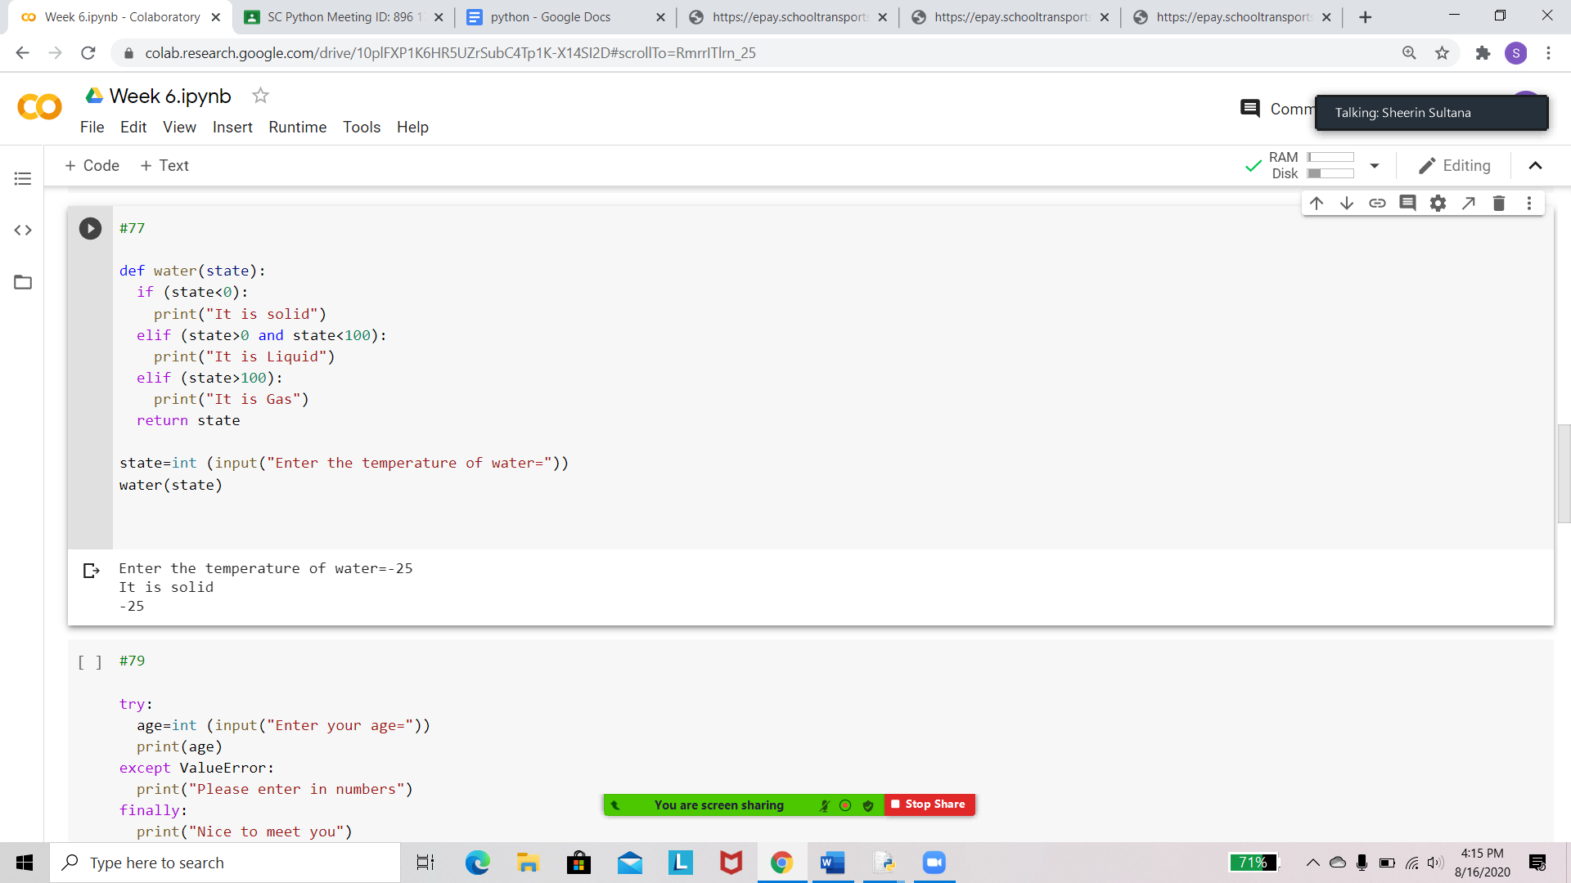

Define a function whatToWear that takes a temperature parameter, and prints :

wear a jacket if the temperature is less than or equal to 50 degrees

wear a sweater if the temperature is between 50 and 70 degrees

wear a t-shirt if the temperature is greater than or equal to 70 degrees

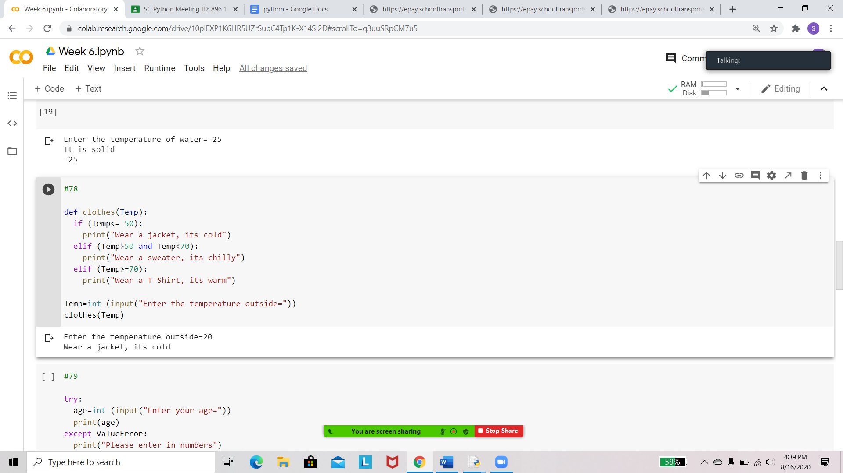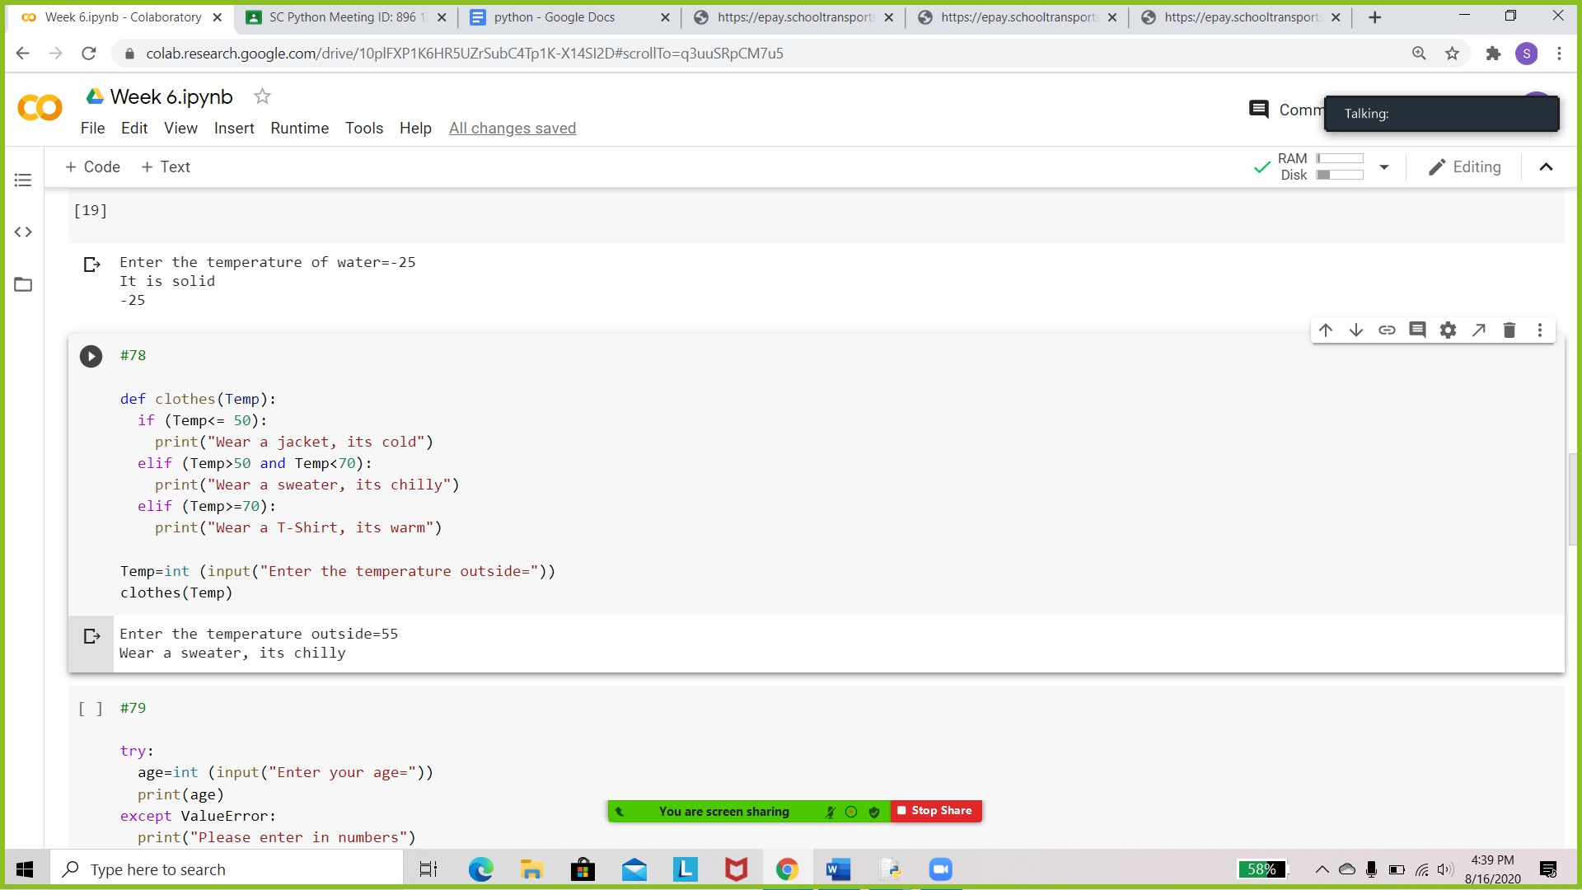

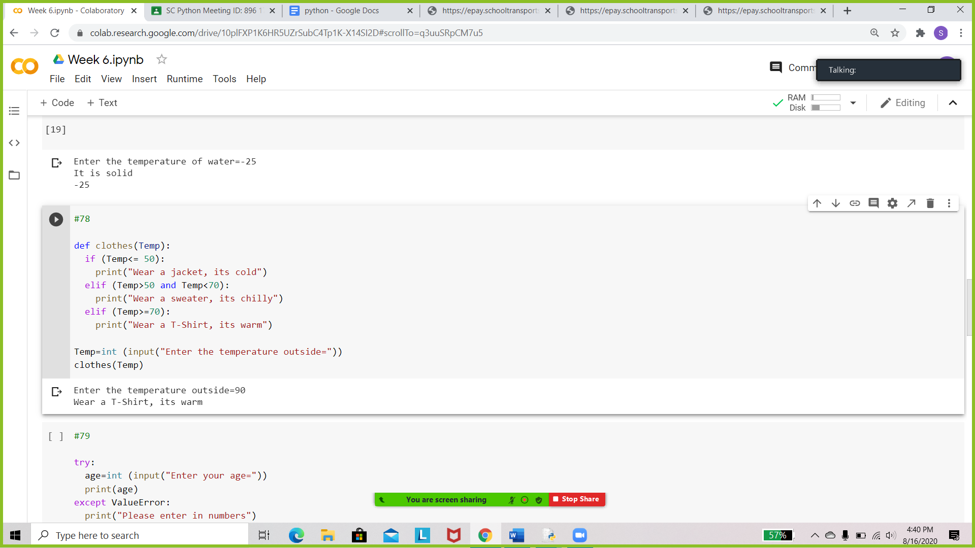

Write a python program to generate a user defined list containing integers using exception handling.

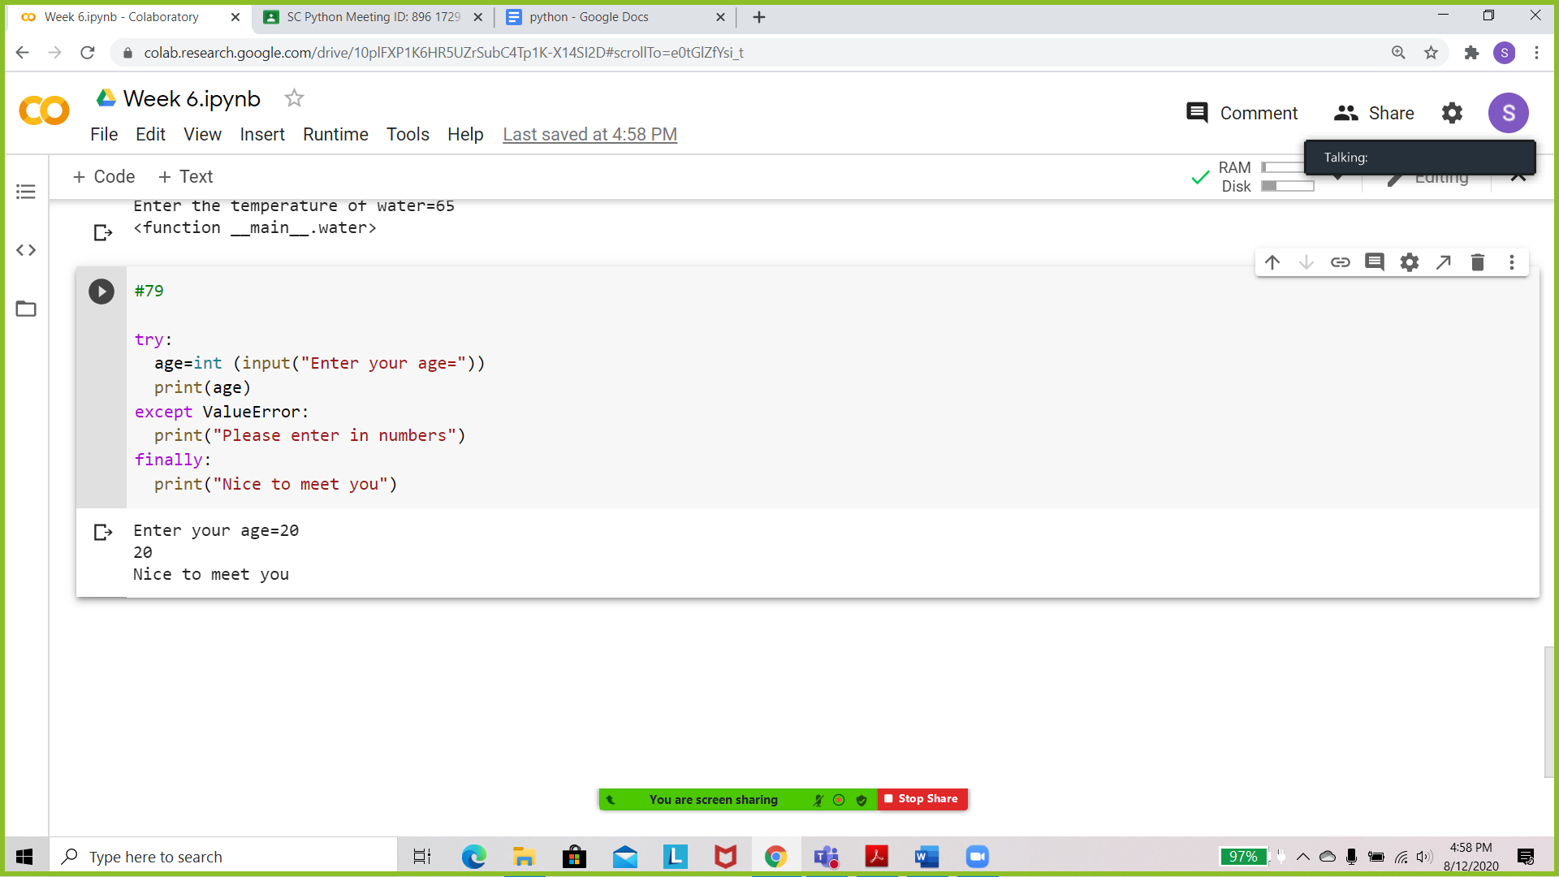 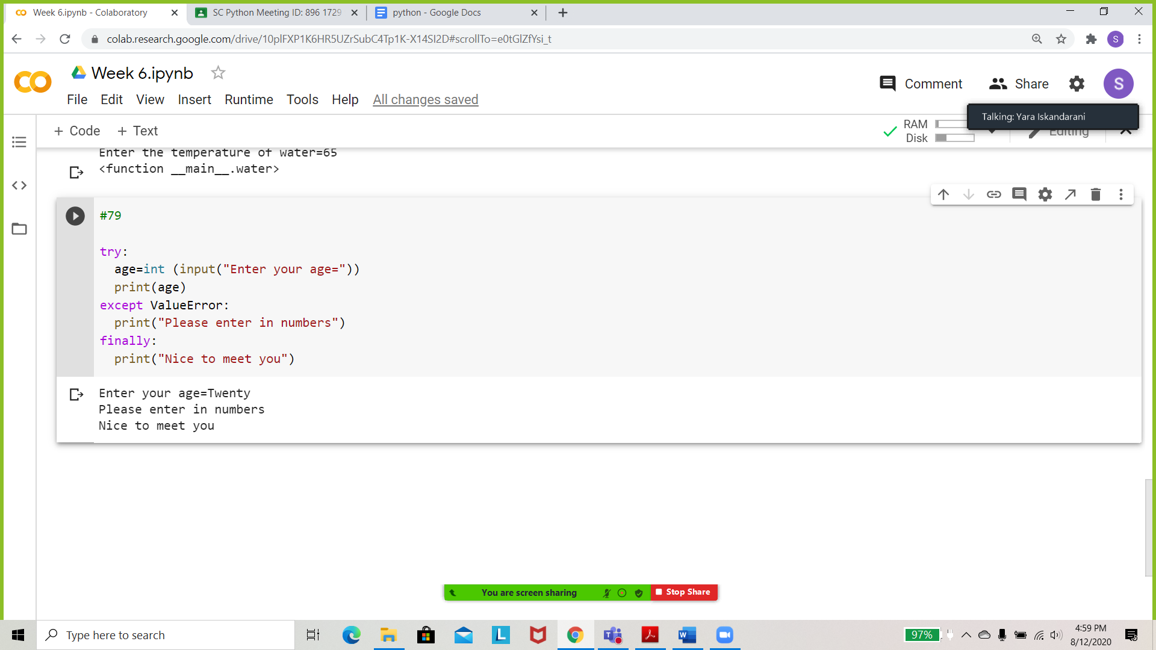

Write a Python program to read an entire text file.

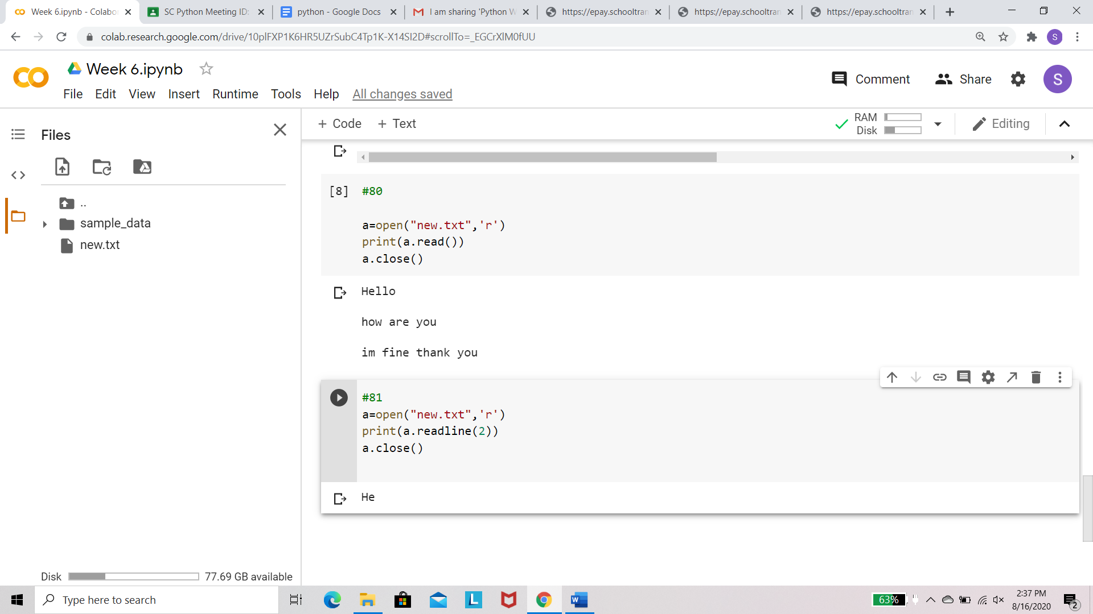

Write a Python program to read the first n lines of a file.



Write a Python program to read a file line by line and store it into a variable.

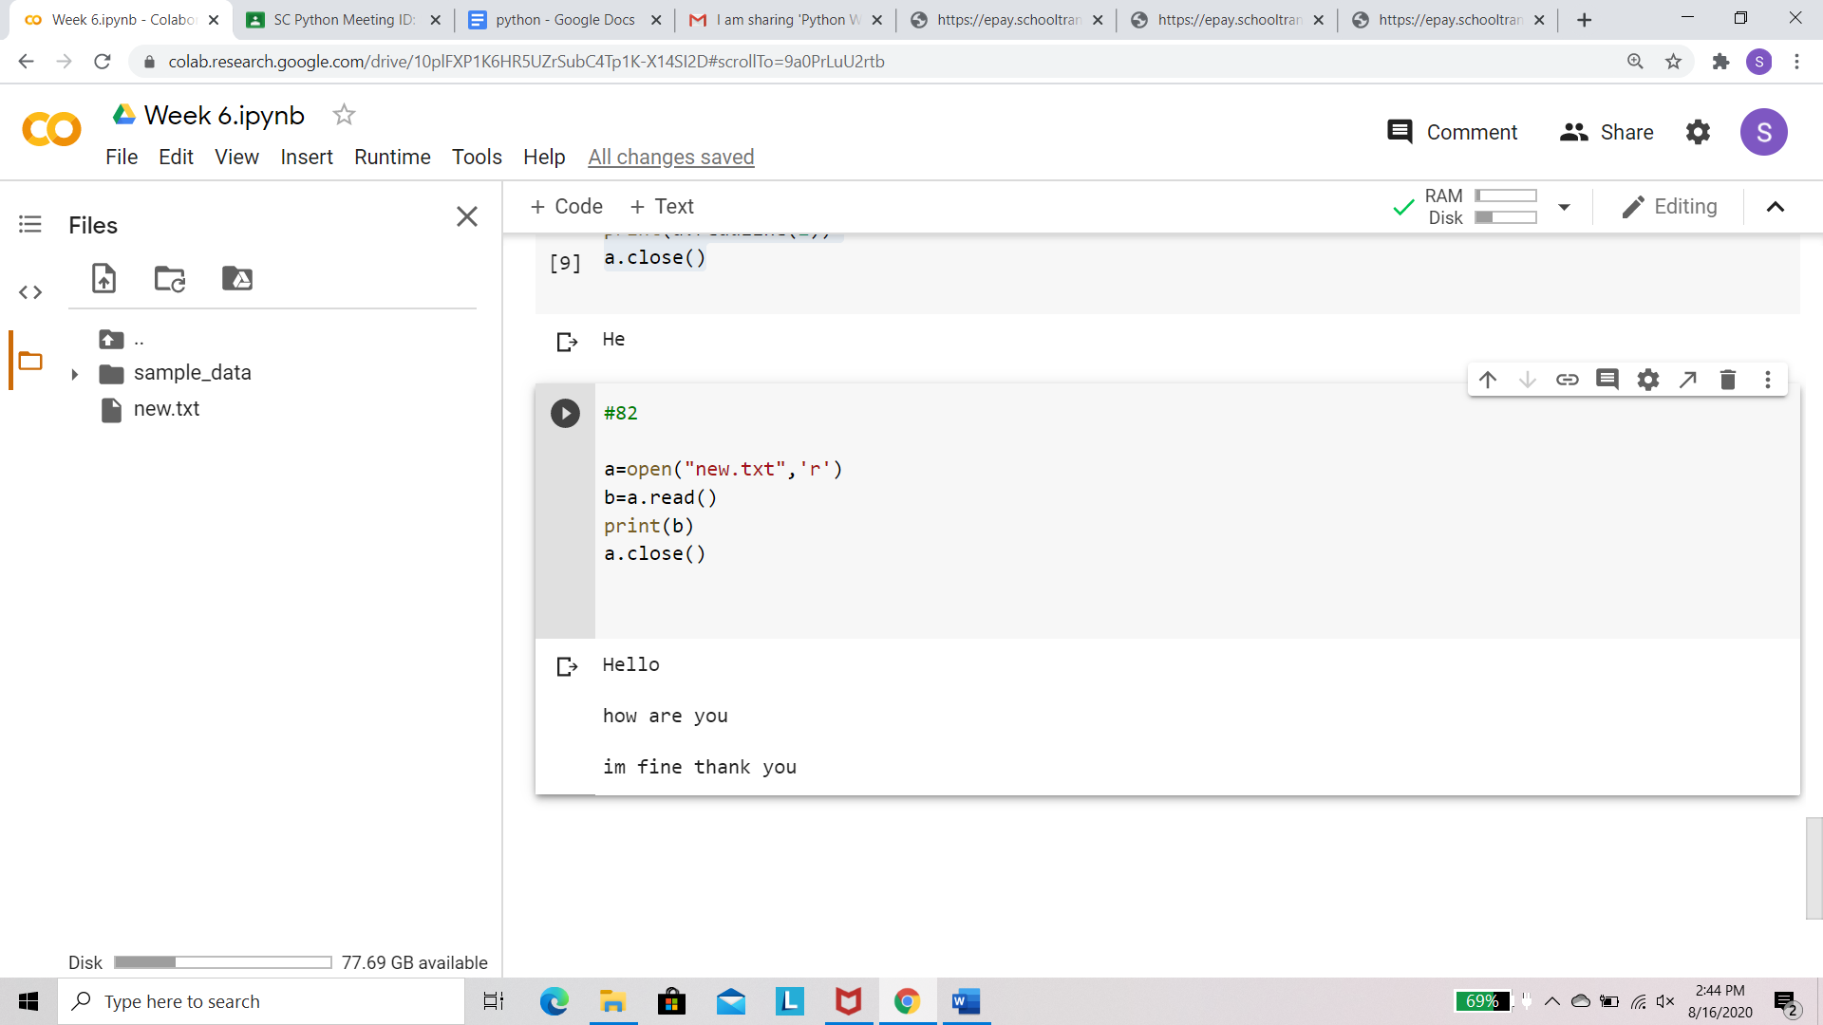

Write a Python program to write a list to a file.

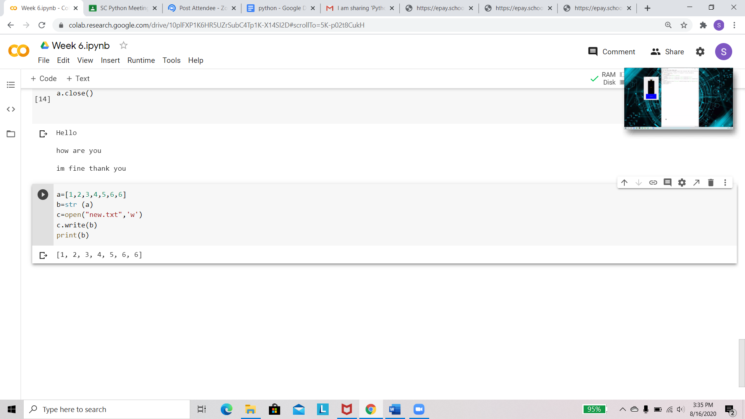

Write a Python program to copy the contents of a file to another file

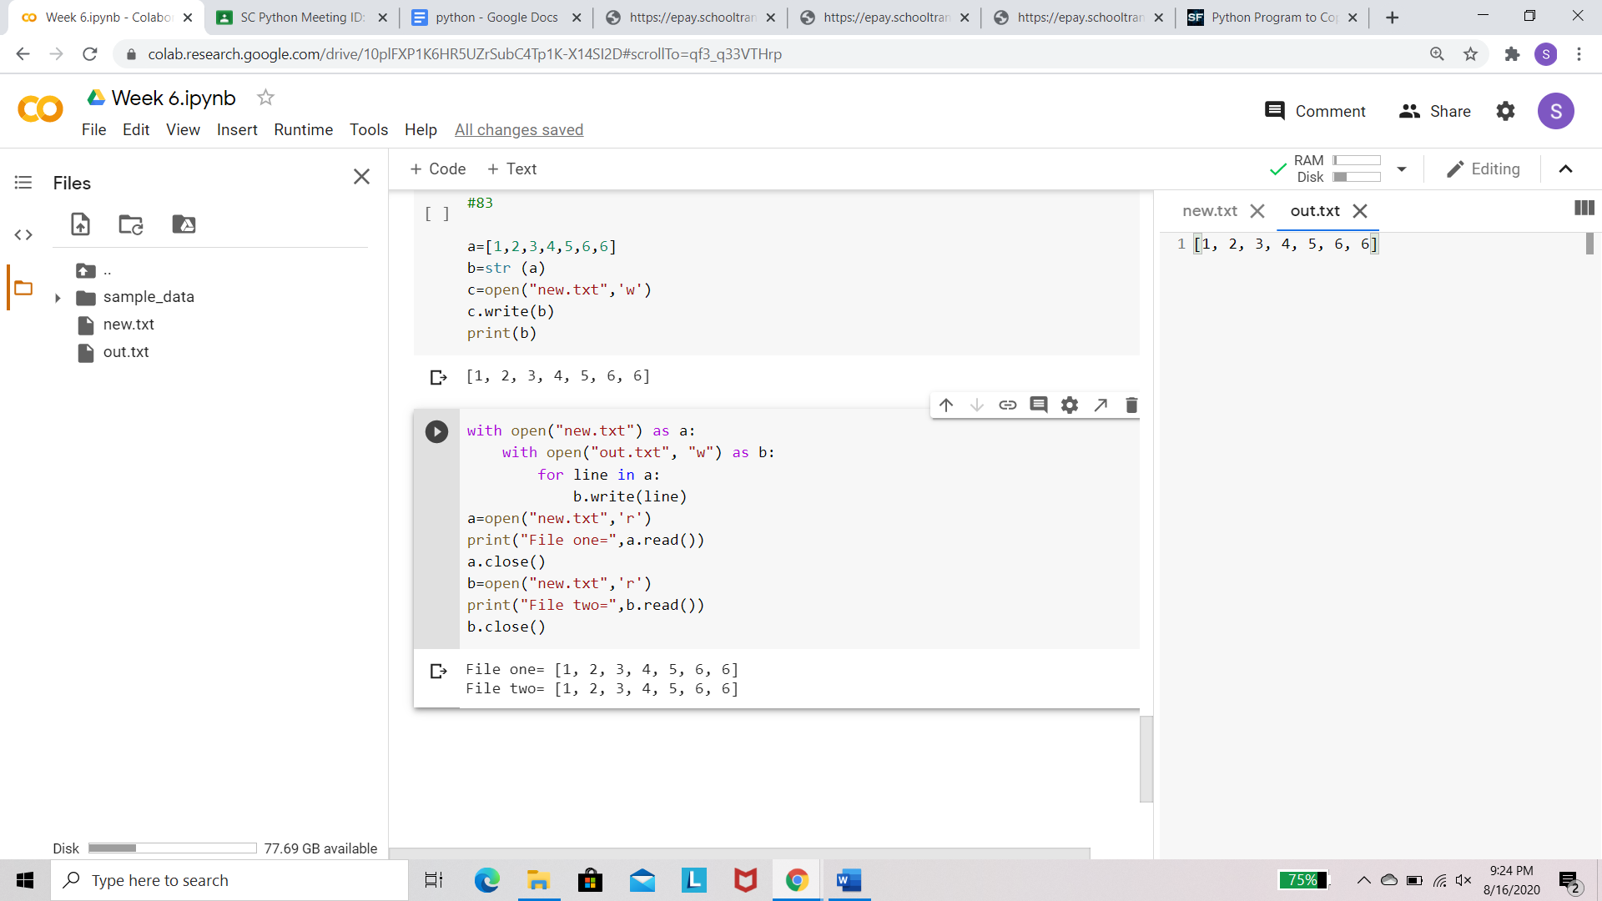

Generate square, hexagon, star using turtle. Make use of different colors.

